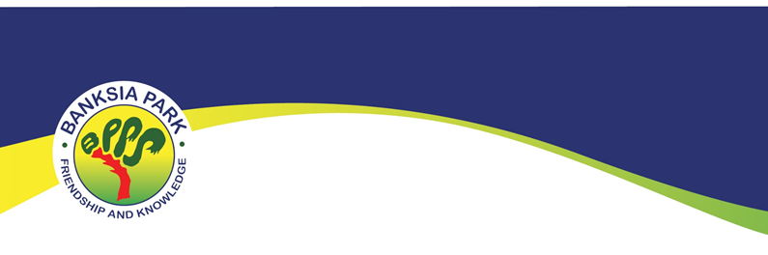

Annual Book Awards Assembly
When | Week 9 or 10 annually
Where | Performing Arts Centre
Who | All classes, Pre-Primary to Year 5 (Year 6 awards are included at their graduation event).
How many? | 2 awards per class (Please note: Year level is not a criterion in choosing recipients. In a split class two students are still selected with no requirement for there to be one from each year level).
Class Awards | Banksia Park Primary School’s motto is Friendship and Knowledge.  Our annual year level awards are aligned to our school motto:  - The Friendship Award – For showing respect, kindness and caring for others. This award recognises a student who exemplifies friendship by being a good friend to others.  - The Knowledge Award - For academic endeavour and learning achievement. This award recognises an individual’s effort in striving to reach their personal potential.
Specialist Awards | Two subject area awards  - Junior (P-2)  - Middle (3-5)  NB: Senior (Yr 6) – Awarded at the Graduation Assembly Year 6
Specialist Award Criteria | Specialist Award recipients:  - Demonstrates an outstanding ability in the subject area.  - Strive to achieve their personal potential.  - Shows initiative in their learning.  - Work to capacity consistently.  - Are willing to challenge themselves and take risks in their learning.  - Consistently demonstrate a high standard of effort and achievement.
Values Aligned | Banksia Park’s school values are Learning, Excellence, Equity and Care. These school values are aligned with the annual classroom awards.  - Friendship – Equity and Care  - Knowledge - Learning & Excellence
Award Criteria | The FRIENDSHIP Award  Award recipients:  - Consistently model friendship values and behaviours such as:  - Respect  - Care  - Kindness  - Consideration  - Fairness  - Cooperation  - Tolerance  - Inclusivity  - Sharing  - Demonstrate a positive attitude to peers and staff.  - Display a consistently high standard of behaviour.  - Participate cooperatively in activities and projects.
Award Criteria | The KNOWLEDGE Award  Award recipients:  - Strive to achieve their personal potential.  - Actively seek to learn and grow academically.  - Work to capacity consistently.  - Are willing to challenge themselves and take risks in their learning.  - Consistently demonstrate a high standard of effort and achievement.  *Please note, this award recipient will be one of the students demonstrating high achievement in a class but is not necessarily the “highest” academically. This award acknowledges the whole child. It recognises a student’s dedication to achieving their full potential, their pursuit of learning, their attitude…along with their high academic results achieved whilst striving to be the best they can be.  This is aligned with our school vision statement.

